**ASSIGNMENT -7**

**Database Trigger (All Types: Row level and Statement level triggers, Before and After Triggers).**

**Create tables and Triggers:**

use dbmspracticals;

create table stud(sid int primary key,name varchar(20),class char(10),age int,issued char(1));

create table returned(sid int,bname varchar(20),bauthor varchar(20));

create table issued(sid int,bname varchar(20));

alter table stud add column bname varchar(20);

delimiter //

create trigger tr_ins_s

before insert

on stud

for each row

begin

insert into issued values(new.sid,new.bname);

end //

delimiter ;

delimiter //

create trigger tr_del_s

after delete

on stud

for each row

begin

delete from issued where sid = old.sid;

end //

delimiter ;

**Insert values into table : stud**

insert into stud values(1,"Om","TE-C",20,"I","DBMS");

insert into stud values(2"saurab","TE-B",21,"I","TOC");

STUD:-

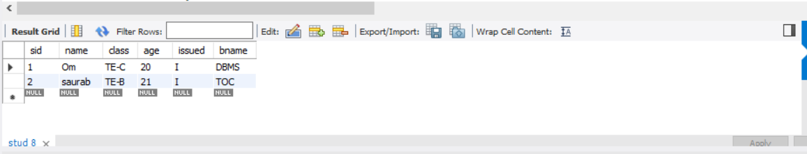

Table ISSUED: values updated by Trigger

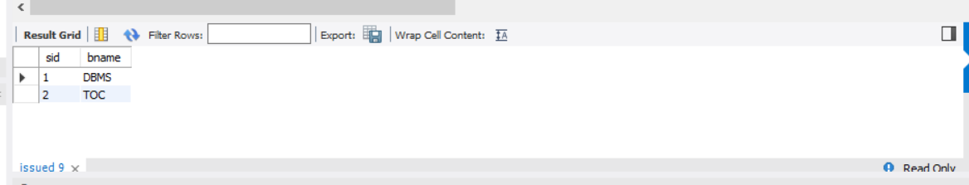

Delete from stud (To call delete_trigger)

delete from stud where sid = 1;

Table stud: (after del statement)

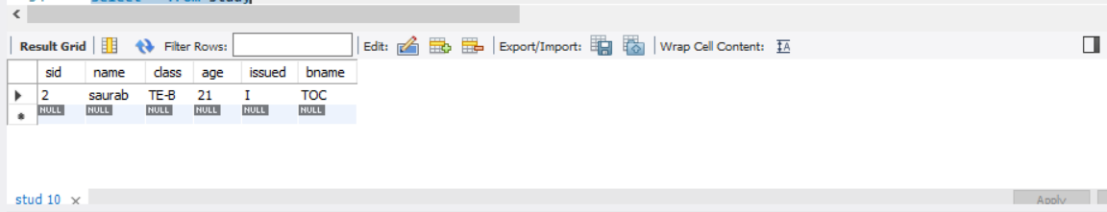

Table ISSUED: values updated by Trigger

